RECEIVER HITCH
Application
PRO-RIDE HITCH - 2010-14 RUSH, 2012-15 SWITCHBACK
Please read these instructions twice and check to be sure all parts and tools are included.
Keep these installation instructions for future reference and parts ordering information.

This kit includes:
Qty |  | Part Descrigtion |  | OEM Ref #
1 |  | Rear Bumper |  | 1018261
1 |  | Rivet |  | 7621467
1 |  | Instructions |  | 9923496

Tools Required:  T-30 Torx Wrench  10 mm Socket  3/16” Drill Bit  Drill  Rivet Gun  Torque Wrench  Racket Wrench | Optional Tools:  Alignment Punch  Small Soft Blow Hammer

IMPORTANT : For your safety, and to ensure a satisfactory installation, perform all installation steps correctly in the
sequence as shown on the attached instructions.

INSTALLATION INSTRUCTIONS
1. Using a T-30 Torx wrench and 10 mm socket  remove the two left hand bumper to rear pivot  mounting nuts and bolts. TIP: You may need to  gently tap on bolts to remove. Repeat this step for  the right hand side. Figure 1. | 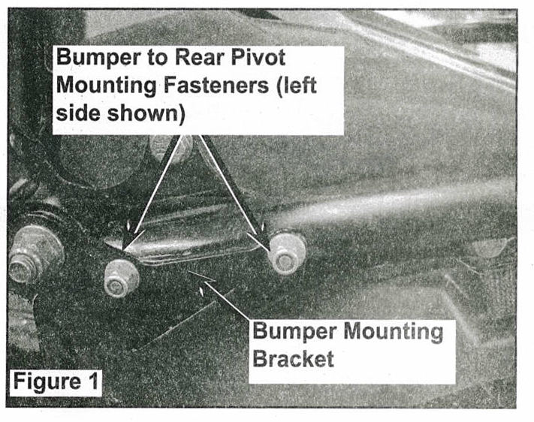

2. Using the 3/16" drill bit, drill out and remove the rivet  that attaches the snow flap support strap to the rear  bumper. Figure 2 | 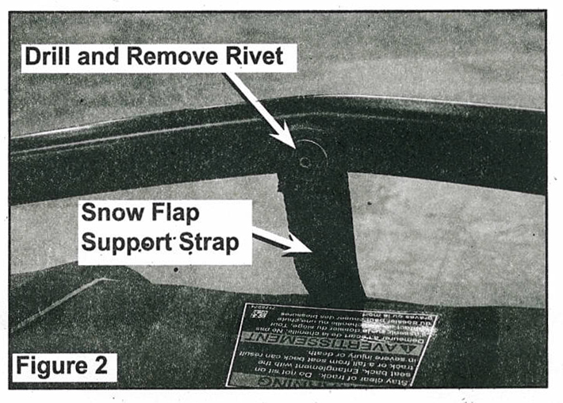

3. Insert the new rivet included in the kit through the snow flap support strap and into the lower mounting hole in the new bumper. Figure 3. Pop the rivet in place with rivet gun. | 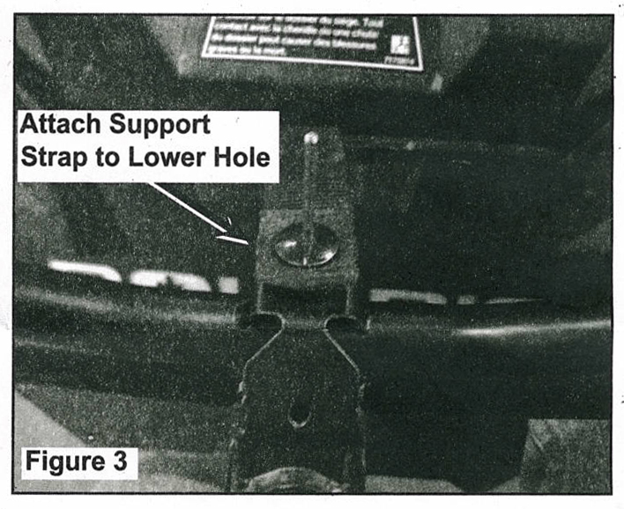

4. Install the new bumper into the bumper mounting
bracket on the rear pivot. Align holes and install the
bumper mounting bolts and nuts. (Refer to Figure 1).
Torque bolts to 7 ft. lbs. TIP: You may need to align
the holes with an alignment punch.

DISCLAIMER: This item is sold without any expressed or implied warranty of merchantability or fitness for a particular purpose. The Manufacturer, Distributor, nor Dealer shall be held liable for any special, incidental, or consequential damages, including damage, loss of revenue, cost purchased or use of this product.

